Working Together- Better Than Ever

Welcome to the 2021 Annual Meeting of the Colorado Horse Council
October 23, 2021
Virtual Meeting – 1:00PM

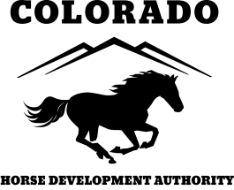
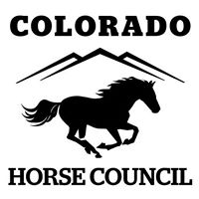
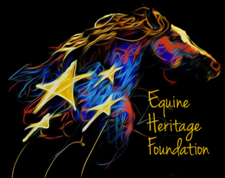
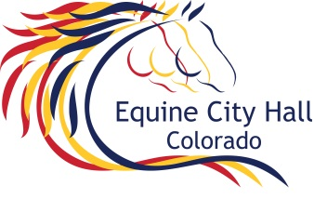
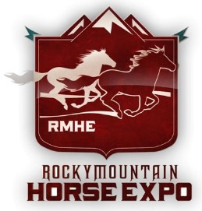

The Colorado Horse Council’s Annual Meeting will provide you with a review of the programs and services that have been accomplished to protect and promote your equine interests. We look forward to your input at this meeting and to your involvement in the many activities, programs and events of the Council. The entire Colorado Horse Council Board invites you to become active in the planning and development of the organization as we serve every equine enthusiast in the state.

There are many who have contributed to this meeting and the success of this year’s activities, programs and events. We want to say thank you to those organizations that have contributed resources that enabled us to move forward on our work. We are fortunate to have the Colorado Horse Development Authority united with our Council which supports the majority of our administrative efforts in keeping the organization operational. We would be remised to not mention and thank the Mile High Racing and Entertainment for continual contributions to the Council in the area of legislation and the donations of resources.

The dedication shown from all of these individuals and organizations make it possible to meet our mission, purpose and goals.

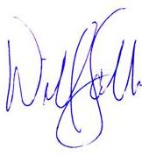
Welcome! We thank you for attending our Annual Meeting and wish you and yours a great Holiday Season.

William (Bill) Scebbi
CEO/ Executive Director
Colorado Horse Council
Equine Heritage Foundation
Colorado Horse Development Authority
Rocky Mountain Horse Expo
Colorado Equine City Hall

